**Assignment**

**COEN 311**

**Computer Organization and Software**

**Assignment #3**

Sunil Kublalsingh

ID: 40212432

Professor: Anjali Agarwal

“I certify that this submission is my original work and meets the

Faculty’s Expectations of Originality”

Sunil Kublalsingh

Student ID: 40212432



February 28, 2022

# Short answer questions

## Question 1

a)



b)

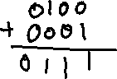

c)



d)

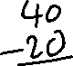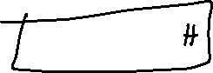

e)

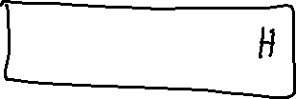

f)

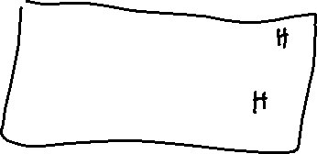

g)

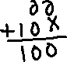

h)

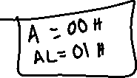

## Question 2

~~MOV AX, [X] ;Place the value of x in register AX~~

~~SUB AX, 4 ; Subtract 4 from AX~~

~~IMUL AX (should go into DX: AX) ;Multiply AX by AX~~

~~IDIV [X] ; Divide AX by X~~

~~ADD AX, 8 ;Add 8 to the answer~~

~~MOV f, AX ; Store result in f~~

section .data

x dw 10

section .text

global _start

_start:

mov cx, [x+0]

mov ax, cx

sub ax, 4

imul ax

idiv cx

_exit:

mov eax,1

mov ebx,0

int 80h

## Question 3

section .data

  isPrime db $FF

number dd 8

section .bss

section .text

global _start

_start:

MOV EAX, [number] ; Place the number in register EAX

IDIV 2 ; Divide EAX by 2, places back into EAX

MOV EBX, EAX ; Place the endpoint in register EBX

MOV EAX, [number] ;Place the original number back into EAX

MOV ECX, 2 ; Use register CX as counter i with starting point i=2

MyLoop:

CMP EBX, ECX ; Check if i has reached the end point

je endLoop ; exit the loop if i==number/2

IDIV ECX ; Divide EAX by ECX, which is number / i, remainder should go into EDX

CMP EDX, 0 ; Check if the remainder is = 0

MOV EAX, [number] ;Place the number back in EAX

je then ; Jump to the stuff in the if condition

INC ECX ; Increment the counter i

jmp MyLoop ; jump back to the start of the loop

then:

MOV [isPrime], $00 ; Set isPrime to false

endLoop:

_exit:

mov eax,1 ; The system call for exit (sys_exit)

mov ebx,0 ; Exit with return code of 0 (no error)

int 80h